**DOCTOR_APPOINTMENT_SYSTEM**

**INTRODUCTION:**

A doctor appointment booking system is **an online system that allows patients to easily book their appointment at a particular clinic related to their health issue**. Such as Dental, Injury, Metal health, Muscle strain, Obesity, Arthritis, Asthma etc.,

**OBJECTIVE:**

The main objective of the project is to book the appointment according the date and time which he wants along with specialized doctor and the people who dont know how to book the appointment they will simply visit our website and we had posted the phone ,email to contact with the receptionist or with the admin.

**GOAL:**

The purpose of the project is **to build an application program to reduce the manual work for managing the Doctor, Appointment, Doctor Fees, Patient**. It tracks all the details about the Patient, Booking, Doctor Schedule.

**MODULES :**

Hospital Landing Page :

1. About ---> Info of the hospital
2. Services ---> Services of the hospital
3. Specialities ---> Doctors and Specialities
4. Contact us ---> Simply send message to the admin
5. Doctors ---> Show the doctors info
6. Admin Login ---> Admin Validation
7. User Login ---> User Validation
8. Contact Infomation ---> Contact Info
9. OTP Validation to reset password ---> Otp will sent to email if people forgot pasowrd

Admin Login :

1) Home ---> Directly take admin to home

2) Cancelled Appointments ---> check cancelled Appointments

3) View Feedbacks ---> he can view feedbacks

4) View Messages and Reply messages via Id ---> reply msgs

5) Add new Admin ---> admin can add new admin

6) View Profile ---> View Profile

7) Add Booking ---> Add patient data data,time

8) Edit Booking ---> Edit the info

9) Delete or cancel Booking ---> Cancel the Appointment

10) Completed Appointment ---> Complete the Appointment

11) Login Again ---> He can login again

12) About Hospital ---> About Hospital

User Login:

1) Booking ----> Booking the Appointment

2) Cancelling ----> Cancel the Appointment

3) Available slots on particular day ----> Available slots on the day

4) Contact to admin ----> Contact to Admin

5) Give feedbacks ----> Give Feedbacks

6) Past feedbacks ----> View Past Feedbacks

7) Booked Appointments ----> View Booked Appointments

8) Cancelled Appointments ----> View past cancelled Appointments

9) Home ----> Directly take them to home page

10) View Profile and Edit Profile -----> View Profile & Edit profile

11) Logout -----> logout and it will go to home page

**EER DIAGRAM:**

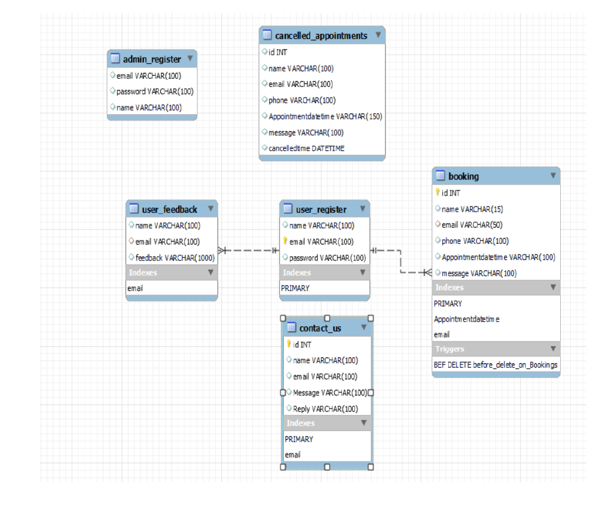

**USER FLOW DAIGRAMS:**

User Login:

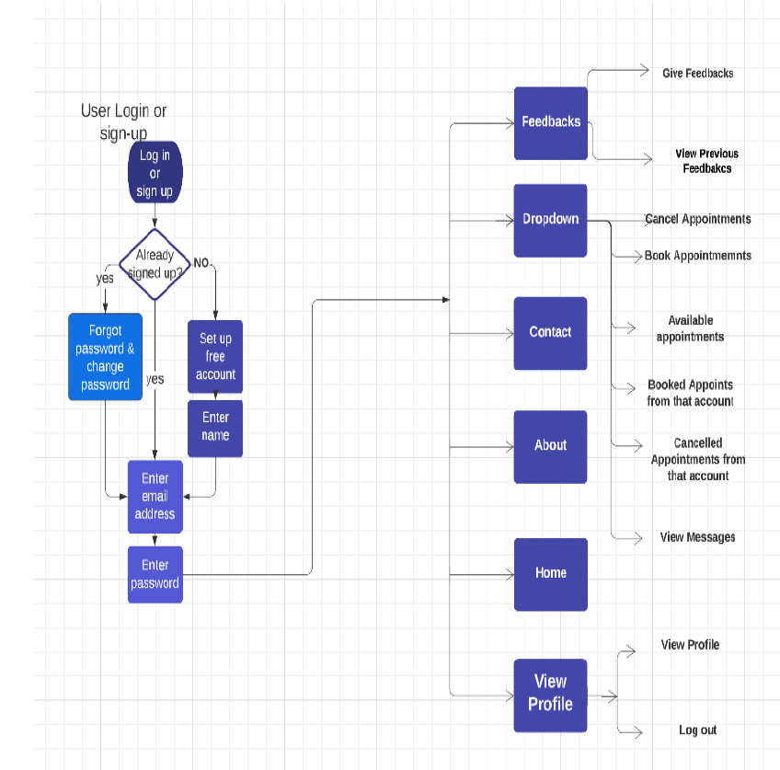

Admin Login: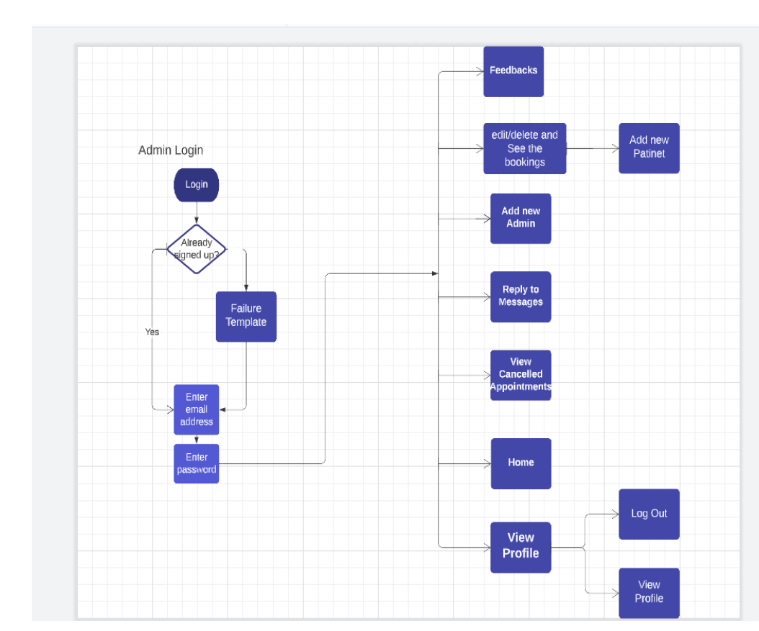

**ADVANTAGES:**

1. 24*7 booking: Anytime Anywhere

2. Organise your schedule better

3. Minimise patient no-shows

4. Making employees and staff more productive

5. Seamlessly integrates with your E.M,R

6. Access appointments on your computer, laptop and mobile phone

7. Improves patient satisfaction

8. Integration with a payment gateway

9. Multiple locations and multiple doctors

**USED TECHNOLOGIES :**

TEMPLATES : HTML, CSS AND JS

BACKEND FUNCTIONALITY : MYSQL , PYTHON_FLASK

### **CONCLUSION:**

Overall, the literature suggests a growing trend for the adoption of Web-based appointment systems. The findings of this review suggest that there are benefits to a variety of patient outcomes from Web-based scheduling interventions with the need for further studies.

3gcvgvcrcrm

ejhcveghcvwchcwdcwhjhchc

a, etc.